**Assignment 29.2**

**Write a hive UDAF to find the largest integer in a column. Use your own dataset for the above problem statement and attach the steps performed, codes used with the result.**

**Here, JAVA code to find the largest integer in the column.**

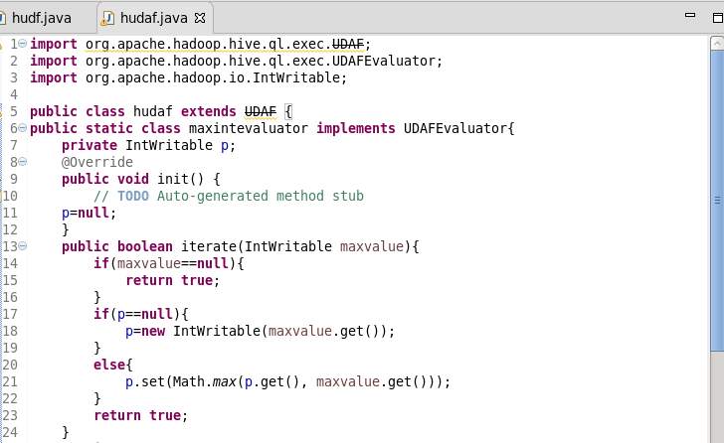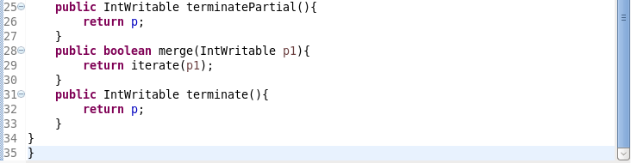

The init() method is called exactly once in an applet's life, when the applet is first loaded. It is used to set up the user interface. Here it initializes the evaluator function.

Then, a loop will run i.e, iterate() method for each value.

First, it will store the value and then using Math.max function it will compare all the values with each other and then get the maximum value out of it.

TerminalPartial() method is used to terminate the process terminally. Then using merge method to combine one partial aggregation with another.

Finally terminate method takes place and will return the largest integer stored in the private variable p.

**Adding jar to hive**

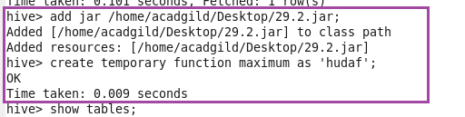

**Showing tables and I will use employee table**

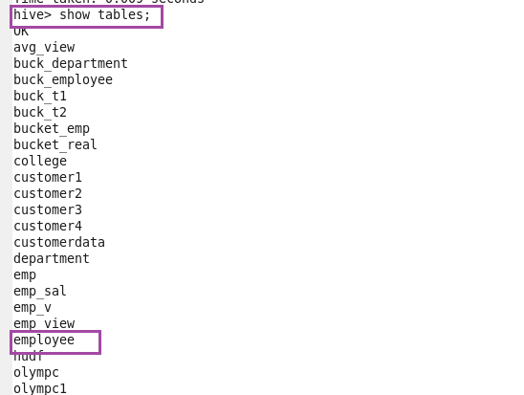

**Displaying and describing all the contents of table employee**

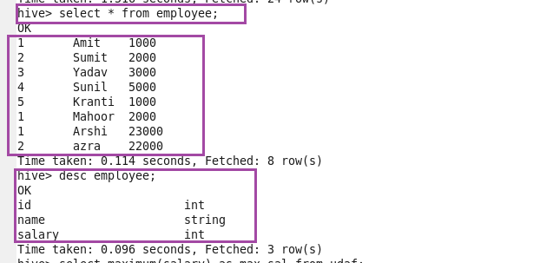

**Using temporary function displaying the largest integer in the salary column.**

